|  |  |  |  |
| --- | --- | --- | --- |
| **Name of Student: NINAD AVINASH PATIL** | | | |
| **Roll No: 33** | | **Lab Practical Number: 2.3** | |
| **Title of Lab Practical: Design a custom exception for Square Root of a negative number. Demonstrate the use of this exception using appropriate GUI.** | | | |
| **DOP: 03/03/2021** | | **DOS: 10/03/2021** | |
| **CO Mapped: CO1** | **PO Mapped: PO3, PO5, PO7,**  **PO12, PSO1, PSO2** | **Faculty Signature:** | **Marks:** |

**Practical No 2.3**

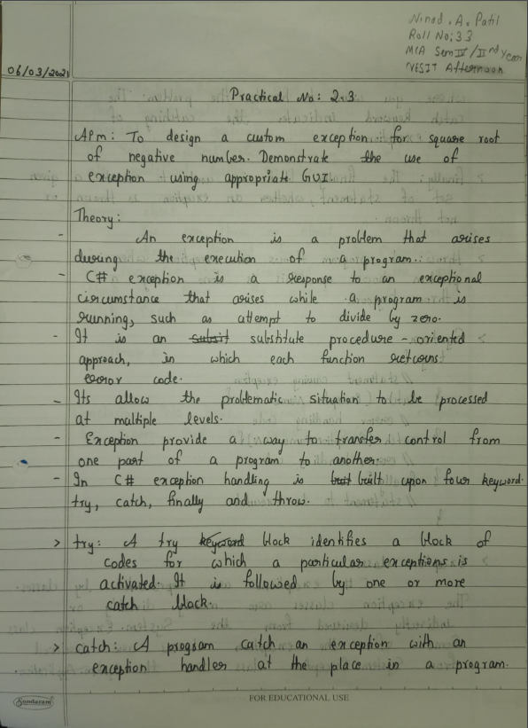

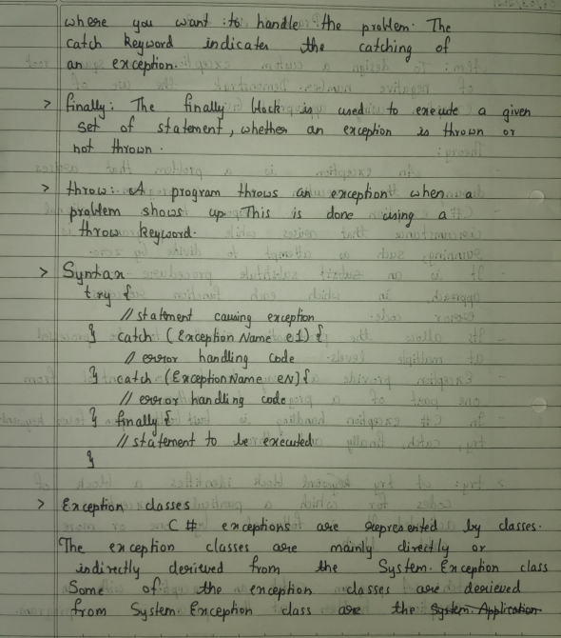

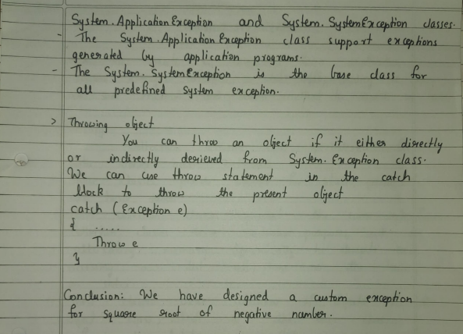

**Code:**

using System;

using System.Collections.Generic;

using System.ComponentModel;

using System.Data;

using System.Drawing;

using System.Linq;

using System.Text;

using System.Windows.Forms;

namespace WindowsFormsApplication2 {

public partial class Form1 : Form {

int ex;

public Form1() {

InitializeComponent();

}

public class square_rootException : Exception {

public square_rootException() {

MessageBox.Show("Cannot Find the Square Root of a negative number");

}

}

private void button1_Click(object sender, EventArgs e) {

double num = double.Parse(textBox1.Text);

try {

if (num < 0) {

throw new square_rootException();

}

else {

double sq = Math.Sqrt(num);

textBox2.Text = sq.ToString(); } }

catch (square_rootException ex) {

MessageBox.Show(ex.Message); } }

private void textBox2_TextChanged(object sender, EventArgs e) {

}

}

}

**Output:**

